Appendix I: Questionnaire Information
Placement/ward awareness questionnaire
I would like to invite you to take part in our research study investigating whether medical students and doctors have a thorough understanding of how wards operate and what factors are related to their level of awareness.
Main researchers: Emma Poynton-Smith (mzyep7@nottingham.ac.uk), Erica Colwill (mzyec13@nottingham.ac.uk)
Supervisor: Professor Opinder Sahota (Opinder.Sahota@nuh.nhs.uk)
It is up to you to decide whether or not to take part: you can give your consent by checking the appropriate boxes on the consent form below. You are free to withdraw at any time and without giving a reason, and withdrawing would not affect your legal rights. However, please note that it is not possible for your information to be extracted and destroyed once you complete and submit the full survey.
If you choose to give your consent to participate using the form below, you will be able to access the next section, which contains questions about your understanding and awareness of hospital wards. It usually takes about 15 minutes to complete.
We will follow ethical and legal practice and all information about you will be handled in confidence: it will be kept anonymous and only viewed by the researchers and authorised persons. It will be stored securely and deleted after 7 years.
The results of the research may be written up with the aim of producing an article or poster for journal presentation. Please be assured that you will not be identified in any report or publication.
If there is anything that is not clear or if you have any concerns, please do not hesitate to contact us using the details provided.

Appendix II: Consent form
Consent to take part
- I confirm that I have read and understand the information above and have had the opportunity to ask questions.
- I understand that my participation is voluntary and that I am free to withdraw at any time, without giving any reason.
- I understand that relevant sections of my information collected in the study may be looked at by the research group and regulatory authorities where it is relevant to my taking part in this study. I give permission for these individuals to have access to these records and to collect, store, analyse and publish information obtained from my participation in this study. I understand that my personal details will be kept confidential.
- I understand that information about me recorded during the study will be kept in a secure database. If the information is transferred, it will be made anonymous. Information will be kept for 7 years after the study has ended.
- I agree to take part in the above study.

Appendix III: Full Questionnaire
Placement/ward awareness questionnaire
*Required
Page 1: Demographics/background
What stage of your training are you at at the moment? *
- Pre-clinical: Year 1
- Pre-clinical: Year 2/GEM1
- Pre-clinical: Year 3/GEM2
- CP1
- CP2
- CP3
- FY1
- FY2
- Trust grade doctor
Are/were you a GEM student? *
- Yes
- No
How old are you?

What is your gender? *
- Female
- Male
- Other: open n
Have you had any paid employment in a healthcare setting? *
- Yes
- No
If so, what did you do? Please select as many as apply and/or type in anything not mentioned in the options available.
- Healthcare Assistant in a hospital
- Healthcare Assistant in a non-hospital environment
- No other patient experience
- Care work in the community (e.g. a care home)
- Care work in a hospital
- Other: open n
Have you had an introduction to the ward environment, i.e. ward etiquette (finding things, staff roles, etc) during your course? *
- Yes, during pre-clinical years
- Yes, during CP1 (first clinical placement)
- Yes, during CP2 (penultimate year)
- Yes, during CP3 (final year)
- No
Have you ever had the opportunity to shadow a nurse (or any healthcare professional other than a doctor) on a ward as part of your medical degree? *
- Yes
- No
How well do you think you understand how hospital wards operate? *
- 1: I completely understand wards
- 2
- 3
- 4
- 5: I have no idea how they work
Page 2: Knowledge assessment
This section will try to quantify how well you understand the ward environment. We are not "testing" you, and we do not expect you to know everything there is to know about wards: we are simply trying to highlight areas which have not been sufficiently covered in the curriculum so far. If you do not know an answer, you can always guess/select or write 'don't know'.
Key (NB: not shown to participants):
Green = fully correct answers, full marks
Yellow = partially correct, half marks
What colour uniforms do the following HCPs wear? *
 | Royal (deep) blue | Light blue | Navy (dark) blue | Grey | Red | White
Ward sister/matron | ⃝ | ⃝ | ⃝ | ⃝ | ⃝ | ⃝
Staff nurse | ⃝ | ⃝ | ⃝ | ⃝ | ⃝ | ⃝
ACP | ⃝ | ⃝ | ⃝ | ⃝ | ⃝ | ⃝
Occupational therapist/physiotherapist | ⃝ | ⃝ | ⃝ | ⃝ | ⃝ | ⃝

Please read the scenarios and select the most appropriate person on the ward to whom you would refer the issue: *
 | Ward sister | Nurse | HCA | ACP | On-call doctor | Consultant
A patient stops you to tell you that they need assistance to go to the toilet. | ⃝ | ⃝ | ⃝ | ⃝ | ⃝ | ⃝
A patient tells you that they are in pain and urgently need more pain relief. | ⃝ | ⃝ | ⃝ | ⃝ | ⃝ | ⃝

Which of the following professions is a healthcare assistant (HCA) linked with? *
- Occupational Therapy
- Nursing
- Physiotherapy
- Physician's Associate
- Don't know
What do the nursing notes contain? Please list as many elements/pages as you can think of. *
Marked out of 2: 3+ correct elements = 2; 1+ correct OR missing key element = 1; No correct elements = 0
Who is responsible for the controlled drugs cabinet on the ward? *
Ward sister/staff nurse/nurse in charge
Who routinely checks patients’ observations (BP, HR, SPO2)? (You can select more than one option.) *
- Nurses
- HCAs
- Junior doctors
- Support workers
- Physiotherapists
- Pharmacists
- Consultants
Are students on clinical placement able to log in and view patient observations/notes? *
- Yes
- No
What does a red wristband on a patient indicate? *
Allergy
Should medical notes be kept in a locked trolley when not in use?
- Yes
- No
How many visitors are typically allowed at the patient bedside? *
- 1
- 2
- 3
- 4
- As many as they like
What does NBM stand for? *
Nil by mouth
How much oxygen is the patient attached to this flow meter on? *
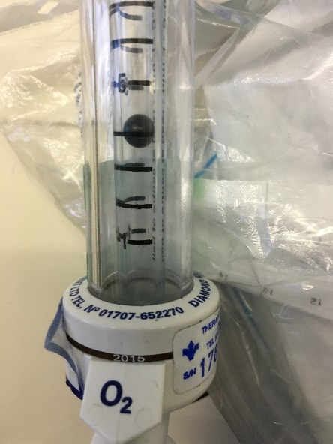
- 3 litres per minute
- 3.5 litres per minute
- 4 litres per minute
- 4.5 litres per minute
- 5 litres per minute
Where would you look to find out about a patient's fluid balance? *
- Doctors' notes
- Nursing notes
- Observations
- Drug chart
- Elsewhere
What does TTO stand for and what does it refer to? *
To take out: medications and paperwork for discharge (‘to take out’ OR ‘discharge medications’)
What is a Waterlow score and who calculates it? *
Risk of developing bedsores, nurses (clerking) (half points for one OR the other)
How many categories are there on the Bristol Stool Chart? *
7
Which lever do you press to make the bed go flat in an acute cardiac arrest? *
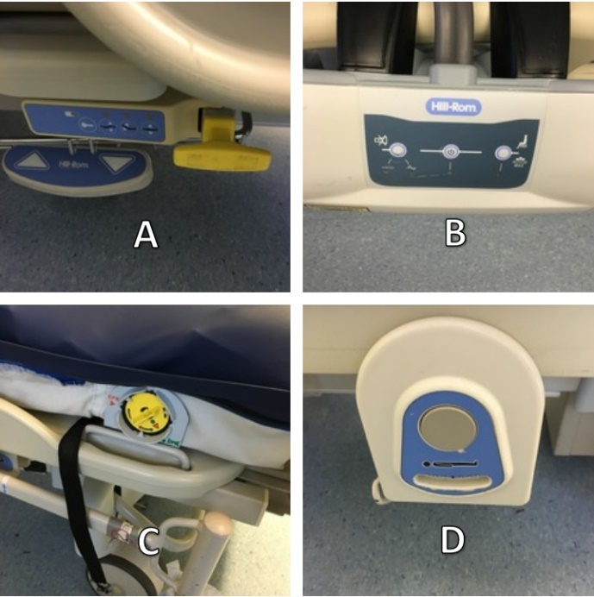
- A
- B
- C
- D
A patient can't hear you - where is the 'on' button for the hearing aid? *
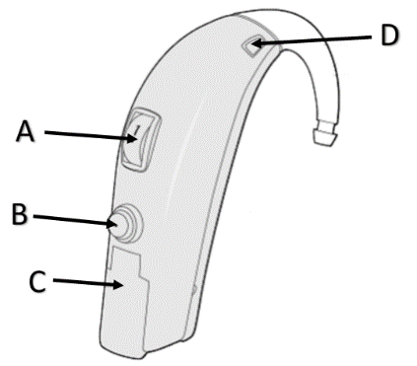
- A
- B
- C
- D
Approximately how long do hearing aid batteries last for? *
- 1 week
- 1 month
- 3 months
A patient has a blue infection control sign on their door and your consultant goes straight in. What should you do? *
- Do nothing: a blue infection control sign just means there are no concerns
- Tell the consultant that they should have washed their hands
- Tell the consultant that they should have worn gloves and an apron
- Discuss it with the ward sister
- Discuss it with the other medical students
Which colour bin should gowns and gloves go in? *
- Black
- Red
- Yellow/Orange
- White
- Blue/Purple
What is this device? *
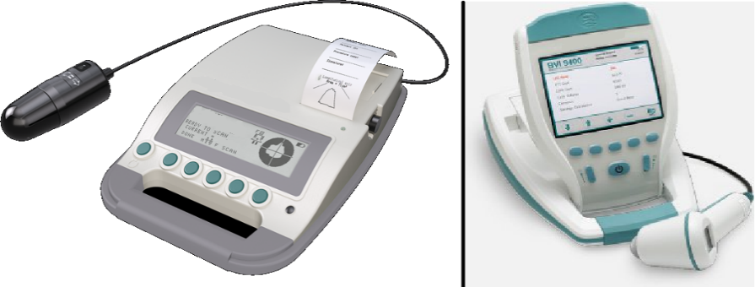
- Doppler machine
- Bladder ultrasound
- Echocardiogram machine
- Sphygmomanometer
Page 3: Follow up
(Optional) Can you think of any way your understanding of wards could be improved?

Would you be interested in attending a practical/teaching session on the topics mentioned in this questionnaire, i.e. how wards function?

(Optional) Please enter your email address here if you would like to be contacted to complete another questionnaire in the future.

To submit, please press the button below!
Thank you very much for your time.

Appendix IV: SPSS Output
Descriptive Statistics
 | Mean | Std. Deviation | N
TotalScore | 17.7857 | 2.90474 | 49
TrainingStage | 1.12 | .389 | 49
GEM | .31 | .466 | 49
Age | 22.80 | 2.041 | 49
Gender | .59 | .497 | 49
HealthcareEmployment | .29 | .456 | 49
HospitalExperience | .12 | .331 | 49
WardIntro | .57 | .500 | 49
ShadowNurse | .84 | .373 | 49
RateUnderstanding | 2.71 | .890 | 49

Correlations
 |  | TotalScore | TrainingStage | GEM | Age
Pearson Correlation | TotalScore | 1.000 | .356 | .365 | .309
Pearson Correlation | TrainingStage | .356 | 1.000 | -.096 | .137
Pearson Correlation | GEM | .365 | -.096 | 1.000 | .659
Pearson Correlation | Age | .309 | .137 | .659 | 1.000
Pearson Correlation | Gender | -.069 | .156 | -.349 | -.331
Pearson Correlation | HealthcareEmployment | .369 | -.084 | .462 | .511
Pearson Correlation | HospitalExperience | .407 | .043 | .562 | .685
Pearson Correlation | WardIntro | -.129 | -.153 | -.051 | -.067
Pearson Correlation | ShadowNurse | .102 | .140 | .174 | .147
Pearson Correlation | RateUnderstanding | -.383 | -.077 | -.237 | -.262
Sig. (1-tailed) | TotalScore | . | .006 | .005 | .015
Sig. (1-tailed) | TrainingStage | .006 | . | .255 | .174
Sig. (1-tailed) | GEM | .005 | .255 | . | .000
Sig. (1-tailed) | Age | .015 | .174 | .000 | .
Sig. (1-tailed) | Gender | .318 | .142 | .007 | .010
Sig. (1-tailed) | HealthcareEmployment | .005 | .284 | .000 | .000
Sig. (1-tailed) | HospitalExperience | .002 | .385 | .000 | .000
Sig. (1-tailed) | WardIntro | .188 | .147 | .364 | .324
Sig. (1-tailed) | ShadowNurse | .244 | .168 | .116 | .157
Sig. (1-tailed) | RateUnderstanding | .003 | .299 | .051 | .034
N | TotalScore | 49 | 49 | 49 | 49
N | TrainingStage | 49 | 49 | 49 | 49
N | GEM | 49 | 49 | 49 | 49
N | Age | 49 | 49 | 49 | 49
N | Gender | 49 | 49 | 49 | 49
N | HealthcareEmployment | 49 | 49 | 49 | 49
N | HospitalExperience | 49 | 49 | 49 | 49
N | WardIntro | 49 | 49 | 49 | 49
N | ShadowNurse | 49 | 49 | 49 | 49
N | RateUnderstanding | 49 | 49 | 49 | 49

Correlations
 |  | Gender | HealthcareEmployment | HospitalExperience | WardIntro
Pearson Correlation | TotalScore | -.069 | .369 | .407 | -.129
Pearson Correlation | TrainingStage | .156 | -.084 | .043 | -.153
Pearson Correlation | GEM | -.349 | .462 | .562 | -.051
Pearson Correlation | Age | -.331 | .511 | .685 | -.067
Pearson Correlation | Gender | 1.000 | -.486 | -.323 | -.132
Pearson Correlation | HealthcareEmployment | -.486 | 1.000 | .591 | .000
Pearson Correlation | HospitalExperience | -.323 | .591 | 1.000 | -.054
Pearson Correlation | WardIntro | -.132 | .000 | -.054 | 1.000
Pearson Correlation | ShadowNurse | -.030 | .035 | -.003 | .175
Pearson Correlation | RateUnderstanding | .108 | -.308 | -.444 | -.094
Sig. (1-tailed) | TotalScore | .318 | .005 | .002 | .188
Sig. (1-tailed) | TrainingStage | .142 | .284 | .385 | .147
Sig. (1-tailed) | GEM | .007 | .000 | .000 | .364
Sig. (1-tailed) | Age | .010 | .000 | .000 | .324
Sig. (1-tailed) | Gender | . | .000 | .012 | .183
Sig. (1-tailed) | HealthcareEmployment | .000 | . | .000 | .500
Sig. (1-tailed) | HospitalExperience | .012 | .000 | . | .356
Sig. (1-tailed) | WardIntro | .183 | .500 | .356 | .
Sig. (1-tailed) | ShadowNurse | .419 | .406 | .491 | .114
Sig. (1-tailed) | RateUnderstanding | .231 | .016 | .001 | .261
N | TotalScore | 49 | 49 | 49 | 49
N | TrainingStage | 49 | 49 | 49 | 49
N | GEM | 49 | 49 | 49 | 49
N | Age | 49 | 49 | 49 | 49
N | Gender | 49 | 49 | 49 | 49
N | HealthcareEmployment | 49 | 49 | 49 | 49
N | HospitalExperience | 49 | 49 | 49 | 49
N | WardIntro | 49 | 49 | 49 | 49
N | ShadowNurse | 49 | 49 | 49 | 49
N | RateUnderstanding | 49 | 49 | 49 | 49

Correlations
 |  | ShadowNurse | RateUnderstanding
Pearson Correlation | TotalScore | .102 | -.383
Pearson Correlation | TrainingStage | .140 | -.077
Pearson Correlation | GEM | .174 | -.237
Pearson Correlation | Age | .147 | -.262
Pearson Correlation | Gender | -.030 | .108
Pearson Correlation | HealthcareEmployment | .035 | -.308
Pearson Correlation | HospitalExperience | -.003 | -.444
Pearson Correlation | WardIntro | .175 | -.094
Pearson Correlation | ShadowNurse | 1.000 | -.081
Pearson Correlation | RateUnderstanding | -.081 | 1.000
Sig. (1-tailed) | TotalScore | .244 | .003
Sig. (1-tailed) | TrainingStage | .168 | .299
Sig. (1-tailed) | GEM | .116 | .051
Sig. (1-tailed) | Age | .157 | .034
Sig. (1-tailed) | Gender | .419 | .231
Sig. (1-tailed) | HealthcareEmployment | .406 | .016
Sig. (1-tailed) | HospitalExperience | .491 | .001
Sig. (1-tailed) | WardIntro | .114 | .261
Sig. (1-tailed) | ShadowNurse | . | .291
Sig. (1-tailed) | RateUnderstanding | .291 | .
N | TotalScore | 49 | 49
N | TrainingStage | 49 | 49
N | GEM | 49 | 49
N | Age | 49 | 49
N | Gender | 49 | 49
N | HealthcareEmployment | 49 | 49
N | HospitalExperience | 49 | 49
N | WardIntro | 49 | 49
N | ShadowNurse | 49 | 49
N | RateUnderstanding | 49 | 49

Variables Entered/Removedª
Model | Variables Entered | Variables Removed | Method
1 | HospitalExperience | . | Stepwise (Criteria: Probability-of-F-to-enter <= .050, Probability-of-F-to-remove >= .100).
2 | TrainingStage | . | Stepwise (Criteria: Probability-of-F-to-enter <= .050, Probability-of-F-to-remove >= .100).

a. Dependent Variable: TotalScore

Model Summary^{c}
Model | R | R Square | Adjusted R Square | Std. Error of the Estimate | Change Statistics
 |  |  |  |  | R Square Change | F Change | df1
1 | .407ª | .165 | .148 | 2.68160 | .165 | 9.321 | 1
2 | .529^{b} | .280 | .249 | 2.51776 | .115 | 7.316 | 1

Model Summary^{c}
Model | Change Statistics
Model | df2 | Sig. F Change | Durbin-Watson
1 | 47 | .004
2 | 46 | .010 | 2.221

a. Predictors: (Constant), HospitalExperience
b. Predictors: (Constant), HospitalExperience, TrainingStage
c. Dependent Variable: TotalScore

ANOVAª
Model |  | Sum of Squares | df | Mean Square | F | Sig.
1 | Regression | 67.024 | 1 | 67.024 | 9.321 | .004^{b}
1 | Residual | 337.976 | 47 | 7.191
1 | Total | 405.000 | 48
2 | Regression | 113.401 | 2 | 56.701 | 8.945 | .001^{c}
 | Residual | 291.599 | 46 | 6.339
 | Total | 405.000 | 48

a. Dependent Variable: TotalScore
b. Predictors: (Constant), HospitalExperience
c. Predictors: (Constant), HospitalExperience, TrainingStage

Coefficientsª
Model |  | Unstandardized Coefficients |  | Standardized Coefficients | t | Sig.
 |  | B | Std. Error | Beta | t | Sig.
1 | (Constant) | 17.349 | .409 |  | 42.424 | .000
1 | HospitalExperience | 3.568 | 1.169 | .407 | 3.053 | .004
2 | (Constant) | 14.526 | 1.112 |  | 13.062 | .000
2 | HospitalExperience | 3.440 | 1.098 | .392 | 3.133 | .003
2 | TrainingStage | 2.529 | .935 | .339 | 2.705 | .010

Coefficientsª
Model |  | 95.0% Confidence Interval for B |  | Correlations
 |  | Lower Bound | Upper Bound | Zero-order | Partial | Part
1 | (Constant) | 16.526 | 18.172
1 | HospitalExperience | 1.217 | 5.919 | .407 | .407 | .407
2 | (Constant) | 12.287 | 16.764
2 | HospitalExperience | 1.230 | 5.651 | .407 | .419 | .392
2 | TrainingStage | .647 | 4.411 | .356 | .370 | .338

Coefficientsª
Model |  | Collinearity Statistics
 |  | Tolerance | VIF
1 | (Constant)
1 | HospitalExperience | 1.000 | 1.000
2 | (Constant)
2 | HospitalExperience | .998 | 1.002
2 | TrainingStage | .998 | 1.002

a. Dependent Variable: TotalScore

Excluded Variablesª
Model |  | Beta In | t | Sig. | Partial Correlation | Collinearity Statistics
 |  |  |  |  |  | Tolerance
1 | TrainingStage | .339^{b} | 2.705 | .010 | .370 | .998
1 | GEM | .200^{b} | 1.246 | .219 | .181 | .684
1 | Age | .057^{b} | .307 | .760 | .045 | .531
1 | Gender | .070^{b} | .490 | .626 | .072 | .896
1 | HealthcareEmployment | .198^{b} | 1.205 | .234 | .175 | .651
1 | WardIntro | -.107^{b} | -.802 | .426 | -.117 | .997
1 | ShadowNurse | .103^{b} | .769 | .446 | .113 | 1.000
1 | RateUnderstanding | -.252^{b} | -1.729 | .091 | -.247 | .803
2 | GEM | .265^{c} | 1.772 | .083 | .255 | .669
2 | Age | -.012^{c} | -.070 | .944 | -.010 | .519
2 | Gender | .005^{c} | .040 | .968 | .006 | .867
2 | HealthcareEmployment | .260^{c} | 1.692 | .097 | .245 | .639
2 | WardIntro | -.058^{c} | -.451 | .654 | -.067 | .974
2 | ShadowNurse | .056^{c} | .442 | .660 | .066 | .980
2 | RateUnderstanding | -.228^{c} | -1.661 | .104 | -.240 | .799

Excluded Variablesª
Model |  | Collinearity Statistics
 |  | VIF | Minimum Tolerance
1 | TrainingStage | 1.002 | .998
1 | GEM | 1.463 | .684
1 | Age | 1.884 | .531
1 | Gender | 1.117 | .896
1 | HealthcareEmployment | 1.536 | .651
1 | WardIntro | 1.003 | .997
1 | ShadowNurse | 1.000 | 1.000
1 | RateUnderstanding | 1.246 | .803
2 | GEM | 1.494 | .669
2 | Age | 1.926 | .519
2 | Gender | 1.154 | .867
2 | HealthcareEmployment | 1.564 | .639
2 | WardIntro | 1.026 | .974
2 | ShadowNurse | 1.020 | .978
2 | RateUnderstanding | 1.251 | .799

a. Dependent Variable: TotalScore
b. Predictors in the Model: (Constant), HospitalExperience
c. Predictors in the Model: (Constant), HospitalExperience, TrainingStage

Collinearity Diagnosticsª
Model | Dimension | Eigenvalue | Condition Index | Variance Proportions
 |  |  |  | (Constant) | HospitalExperience | TrainingStage
1 | 1 | 1.350 | 1.000 | .33 | .33
1 | 2 | .650 | 1.441 | .67 | .67
2 | 1 | 2.154 | 1.000 | .02 | .06 | .02
2 | 2 | .791 | 1.650 | .01 | .94 | .01
2 | 3 | .054 | 6.311 | .97 | .00 | .97

a. Dependent Variable: TotalScore

Casewise Diagnosticsª
Case Number | Std. Residual | TotalScore | Predicted Value | Residual
28 | -2.206 | 11.50 | 17.0548 | -5.55478
37 | -2.183 | 15.00 | 20.4952 | -5.49519
47 | -2.008 | 12.00 | 17.0548 | -5.05478

a. Dependent Variable: TotalScore

Residuals Statisticsª
 | Minimum | Maximum | Mean | Std. Deviation | N
Predicted Value | 14.5259 | 23.0241 | 17.7305 | 1.48956 | 53
Std. Predicted Value | -2.121 | 3.408 | -.036 | .969 | 53
Standard Error of Predicted Value | .399 | 1.290 | .548 | .269 | 53
Adjusted Predicted Value | 14.2898 | 23.2105 | 17.7245 | 1.51931 | 53
Residual | -5.55478 | 3.44522 | -.01357 | 2.40555 | 53
Std. Residual | -2.206 | 1.368 | -.005 | .955 | 53
Stud. Residual | -2.396 | 1.456 | -.004 | .985 | 53
Deleted Residual | -6.62468 | 3.93112 | -.00754 | 2.56235 | 53
Stud. Deleted Residual | -2.534 | 1.474 | -.009 | 1.003 | 53
Mahal. Distance | .221 | 11.617 | 1.828 | 2.970 | 53
Cook's Distance | .000 | .393 | .022 | .057 | 53
Centered Leverage Value | .005 | .242 | .038 | .062 | 53

a. Dependent Variable: TotalScore

Charts

